CHANGE CONTROL

VERSION | DATE | CHANGES | AUTHOR
1.0 | 06/09/2020 | New Document | Aleo Ralph C. De Leon

APPROVAL OF THE DOCUMENT

ROLE | NAME | DATE
RPA LEAD DEVELOPER
SERVICE OPERATION MANAGER

- INTRODUCTION
  - PURPOSE OF THE DOCUMENT
The purpose of this document is to outline the deployment information related to the implementation of Robotics Process Automation (RPA) using UiPath for the process of Ookla RPA. This details the preconditions in running the robot/s, maintenance activities for the robot/s, schedule of operations, and issue categorization for business reference.

The key features of the automated process demonstrate the following:
- Automated extraction of latest files from Ookla
- Automated dumping of files from machine to 10.8.73.70@/apps/DASHBOARD/BROADBAND/done/RAW_DATA

  - SCOPE
This document covers the definition of terms used in Ookla RPA preconditions on running the robot, manually running the robots, monitoring the robots, and troubleshooting. Also covered in this document are the contact information of the key persons in the deployment and operation of the processes and contingency plans.

- DEFINITIONS
  - DEFINITION OF TERMS
TERMINOLOGY | DEFINITION
UiPath Studio | A software used for developing automation tool
UiPath Robot | Executes the processes built in UiPath Studio
UiPath Orchestrator | A web application that orchestrate UiPath Robots in executing repetitive business processes
WinSCP | A software that creates a secure file transfer between a local and a remote computer.

  - ACRONYMS
ACRONYM | DEFINITION
RPA | Robotics Process Automation
VPN | Virtual Private Network

- VERSION CONTROL
  - LIST OF PROCESS DEPLOYMENTS
DATE | PACKAGE IDENTIFICATION | DESCRIPTION OF CHANGES
06/03/2020 | 1.0.0 | Initial Release

  - LATEST VERSION INFORMATION

VERSION: 1.0.0
PACKAGE NAME | Ookla_RPA
PACKAGE DATE CREATED | June 3,2020
RELEASE NAME | Ookla_RPA
RELEASE DATE CREATED | June 4,2020
RELEASED BY | Aleo Ralph C. De Leon
RELEASED FOR | Deployment
PURPOSE OF RELEASE | Deployment for testing
RELEASE FILE LOCATION

- ROBOT/S
  - PRECONDITIONS ON RUNNING THE ROBOT/S
    - PACKAGE
To verify if the package is already uploaded in the orchestrator:
- Login to UiPath Orchestrator
- Click existing Orchestrator Services
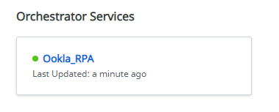
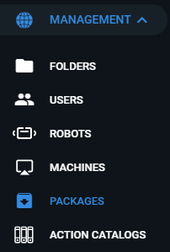
- Click Packages under the Management

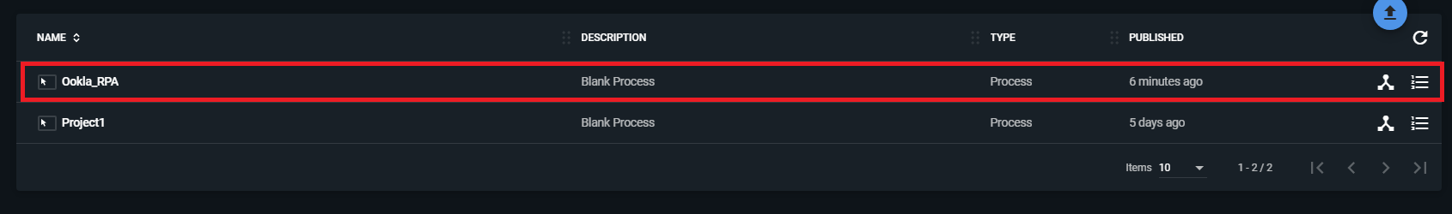
4. Check if Ookla_RPA is present

    - ROBOT
- Login to UiPath Orchestrator
- Click existing Orchestrator Services
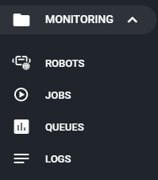
- Click Robots under the Monitoring

- The status of the Robot is located on the left side.

- The possible statuses of the robots are listed below:
- Available - the Robot is not running a process and is free to be used; or waiting for the scheduled activity.
- Busy - the Robot is running a process;
- Unresponsive - the Robot and Orchestrator have not communicated in the last two minutes - the default scenario.
- Disconnected - the UiPath Robot service is not running.
    - ASSETS
N/A
    - SCHEDULE
To ensure that the schedule is configured
- Login to UiPath Orchestrator
- Click existing Orchestrator Services
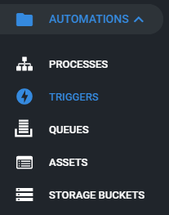
- Click Triggers under Automations

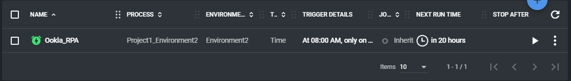
- Make sure that the schedule is correct

    - OTHER PRECONDITIONS
- Ensure that the UiPath for Chrome is installed for the robot to work.
- Machine must be connected to Citrix VPN

  - MANUALLY RUNNING THE ROBOT/S
In any case, the robot have to run out of the predefined schedule set in orchestrator (see Section 4.1.4 for the Scheduling), steps in manually running the robot are stated below:
- Run UiPath Assistant
- Double click UiPath Assistant in taskbar
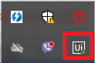
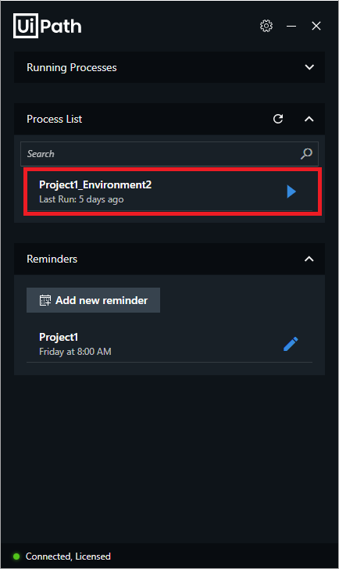
- Click the start under the Process

  - MONITORING THE ROBOT/S
    - HEARTBEAT OF THE ROBOT/S
To check the heartbeat of the robots:
- Click Robots under the Monitoring
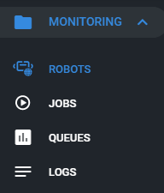

- Click Folder Overview beside Robots

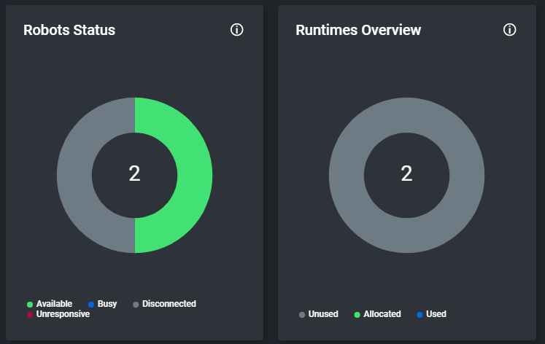
- The graph will show the status of each Robots

  - ALERTS
Alerts will impact the process and business drivers. There may be a requirement for them to execute actions based on the alerts produced. In this section if they number all the alerts and their communication method and how to act in face of all the alerts produced by the robot, it must be in the ODH.
ALERT MESSAGES | SYSTEM  OR  BUSINESS | COMMUNICATION  METHOD AND  RECIPIENTS | ACTIONS  OPERATION OR BUSINESS TO TAKE | EXPECTED RESPONSE TIME
Task Completed | System |  | Click Ok

  - TROUBLESHOOTING
    - ROBOT/S STOP RUNNING
When the robot/s stopped running, there are two reasons as to why it happened:
● Robot/s stopped running the job; or
● Robot/s became Unresponsive or Disconnected

    - ROBOT/S STOP RUNNING THE JOB
The Robot will only stop if the process is done

    - ROBOT/S BECOME/S UNRESPONSIVE OR DISCONNECTED
If robot becomes unresponsive or disconnected:
- Rerun the Orchestrator.
- Check whether robot is connected.
- Make sure to check the Preconditions on running the robot.
- RUNTIME GUIDE
  - RUNTIME DIAGRAM [ARCHITECTURAL STRUCTURE OF THE MASTER PROJECT]
The package created from UiPath studio will be deployed to the UiPath Orchestrator. The Orchestrator will then pass the package to the robot. The robot will run the task every week on Friday at 8 AM.
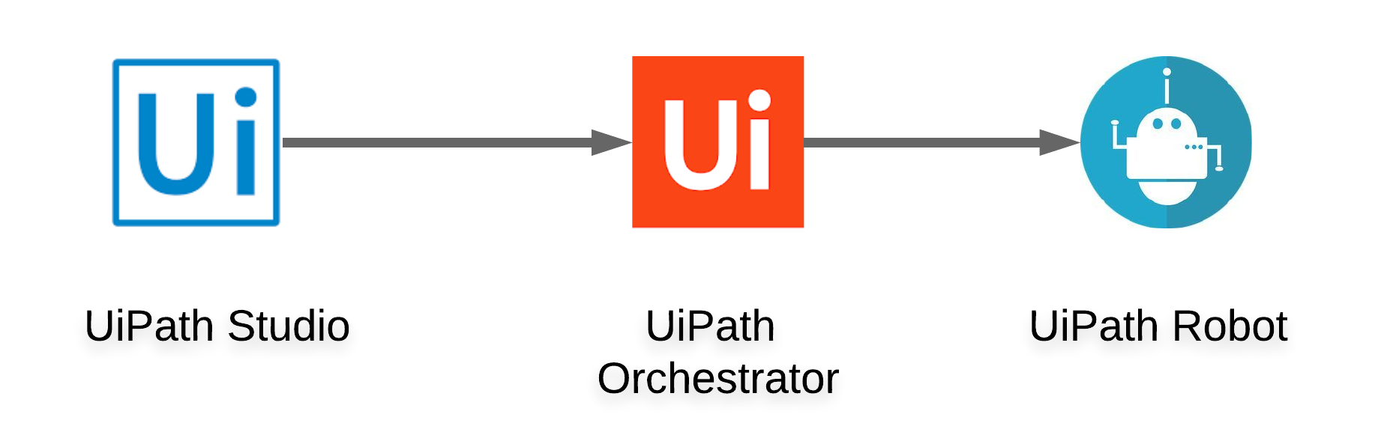
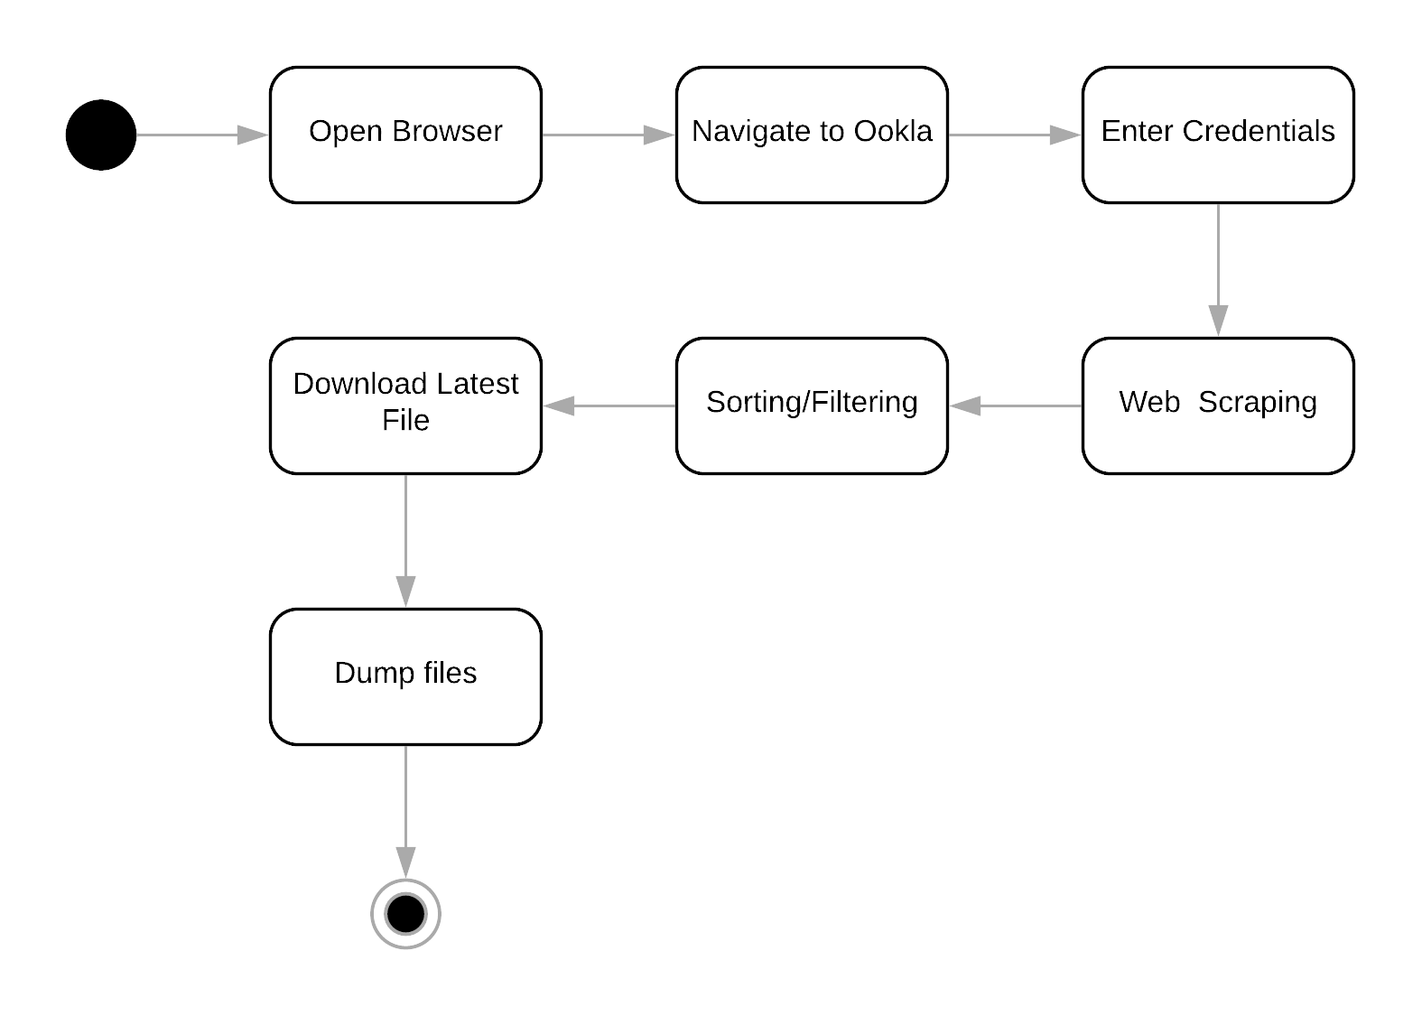
The robot will first open the browser then it will automatically enter the credentials needed to access the webpage. The robot will extract the list of text from the webpage then it would be filtered to remove the unnecessary text and sorted in descending order. The robot will then download the file based on the sorted text and it will be dumped to 10.8.73.70 using WinSCP.

  - LIST OF PACKAGES
PACKAGE | HIGH-LEVEL DESCRIPTION
1.0 | Initial Release

  - MASTER PROJECT RUNTIME DETAILS
Details of the automated process.
 | DETAILS | DESCRIPTION
1 | Production environment details | Local environment
2 | Prerequisites to run | - UiPath Chrome web plugin  - Close all browsers
3 | Input Data | N/A
4 | Expected Output  (output data) | Latest files for Windows, IOS and Android
5 | How to start the automated process? | - Manual Run (UiPath Robot)  - Schedule Run (Schedule in Orchestrator)
6 | Resuming the process from a particular step | N/A
7 | Reporting  (queues reporting, Kibana or another  platform) | N/A
8 | Manual Error Handling  (Roll back or manually complete failed transactions). Procedures to reset the item. Ex “set status as investigating” | N/A
8 | a. How to resume the  process in case of error | Restart the UiPath Orchestrator and run again
8 | b. How to manually fix  transactions with error | Restart the UiPath Orchestrator and run again
9 | Use of Orchestrator | Yes
9 | Password policies (specific compliance requests?) | N/A
9 | Stored Credentials: (Never hardcode credentials in the workflow) | N/A
9 | List of Asset Names: (Follow naming convention ProcessName_AssetName) | N/A
9 | List of Queues Names (Follow naming convention ProcessName_QueueName) | Ookla_RPA
9 | Schedule details: | Every week on Friday at 8 AM
10 | Multiple resolutions supported (in case of image automation/ Citrix) | N/A
10 | Recommended resolution | N/A

- IMPLEMENTATION
  - IMPLEMENTATION PLAN
    - SYSTEM / RESOURCE CONFIGURATION

SYSTEMS | DESCRIPTION | VERSION  (Optional) | IDENTIFIER  (Optional)
Orchestrator | A web application that orchestrate UiPath Robots in executing repetitive business processes
Web plugin | A plugin to perform browser automations

    - CRITERIA OF COMPLETION OF THE EXECUTION AND VERIFICATION
- Executed the process and completed successfully
- Downloaded the latest files from Ookla

  - IMPLEMENTATION GOVERNANCE
N/A
  - IMPLEMENTATION SCHEDULE
NO | TASK | DEPENDENT ON TASK | START TIME | FINISH TIME | DATE | OWNER | COMMENTS
June 3, 2020
1 | UAT |  | 1:00 PM | 3:00 PM | June 3, 2020 | Aleo Ralph C. De Leon

  - CONTINGENCY AND BACKSPACE
NO | SCENARIO | ACTION REQUIRED | OWNER

- CONTACTS
  - BUSINESS OPERATIONS TEAM
NAME | CONTACT NUMBERS | ROLE RESPONSIBILITY | AVAILABILITY  (FROM-TO) | ESCALATION ROUTE

  - RPA DELIVERY TEAM
NAME | CONTACT NUMBERS | ROLE RESPONSIBILITY | AVAILABILITY  (FROM-TO) | ESCALATION ROUTE

  - SUPPORT AND OPERATIONS TEAM
NAME | CONTACT NUMBERS | ROLE RESPONSIBILITY | AVAILABILITY  (FROM-TO) | ESCALATION ROUTE

